# *TRAGEDY OF FLIGHT – A COMPREHENSIVE CRASH ANALYSIS .*

**Our Hard working team**

M.Snegadharshini

K.Meena Pon Abirami

P.Evangeline christina

C.Priyadharshini

**College** **Name** :

Govindammal Aditanar college for women

Tiruchendur.

**1.INTRODUCTION**

**1.1. Overview**

An airplane crash analysis is a detailed investigation into the causes of an aviation accident. The goal of an airplane crash analysis is to identify any factors that contributed to the accident, with the ultimate goal of improving safety and preventing future accidents. The process of conducting an airplane crash analysis typically involves the collection and analysis of a wide range of data, including information about the aircraft and its systems, the operators, and any other relevant factors. This data is typically collected from Kaggle. Once the data has been collected, it is analysed through tableau, to identify any potential causes of the accident. The results of an airplane crash analysis are typically published in a report, which may include recommendations for improving safety and preventing similar accidents in the future. These recommendations may be implemented by the relevant authorities or industry organizations.

**1.2.Purpose**

* We discover the hazards that led to the accidents and to product their recurrence in a future accident.
* We can find solution to minimize airplane crash .
* We gained a thorough knowledge about TABLEAU and MYSQL
* We gained knowledge about the tragedies based on the years.

**2. Problem Definition &Design thinking**

**2.1. Empathy Map**

We can define problem-solving as a process of understanding the problem, designing an algorithm for it, and finally implementing the solution to it. Therefore, we can say that a successful problem-solving process depends on the following factors: understanding the problem and defining it precisely. We created the Empathy Map to define and understand the problem . Our empathy map is shown below .

Here we included the says , thinks, do's and feels of people about the problem.

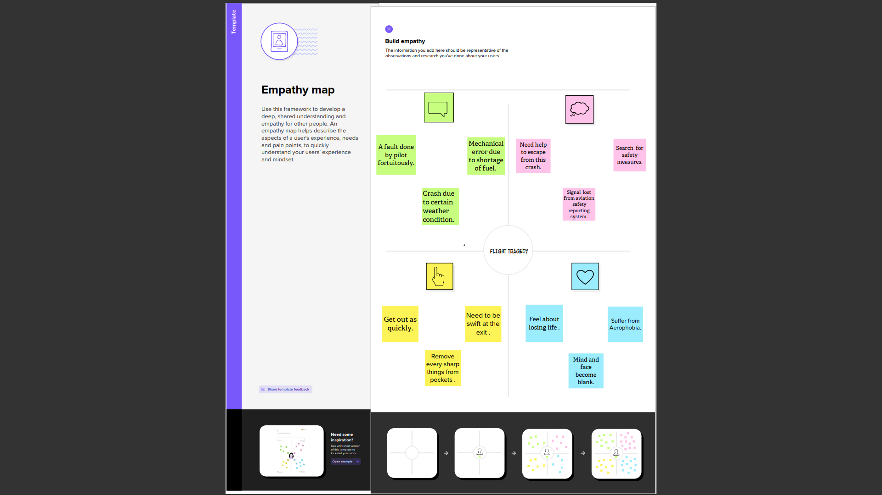

**2.2 Ideation & brainstorming**

We collected various ideas from several persons to solve this problem. The survey is mentioned below.

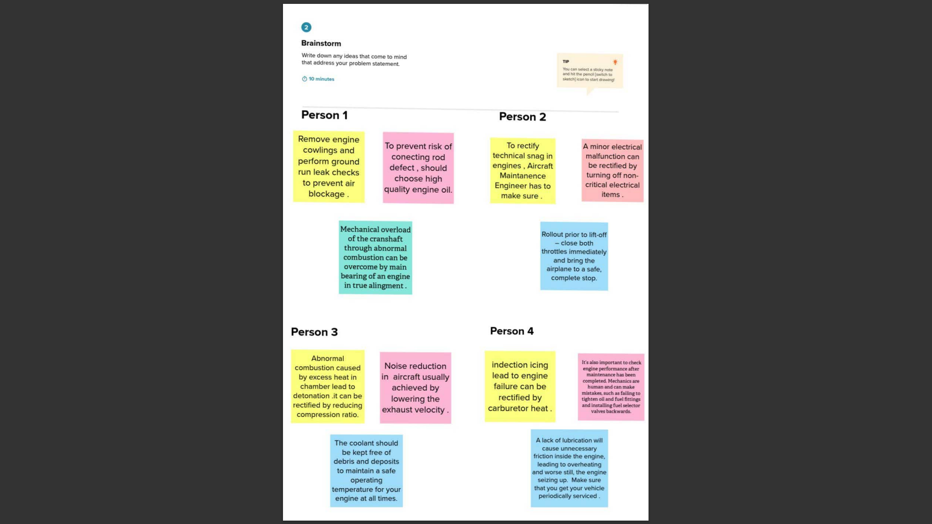

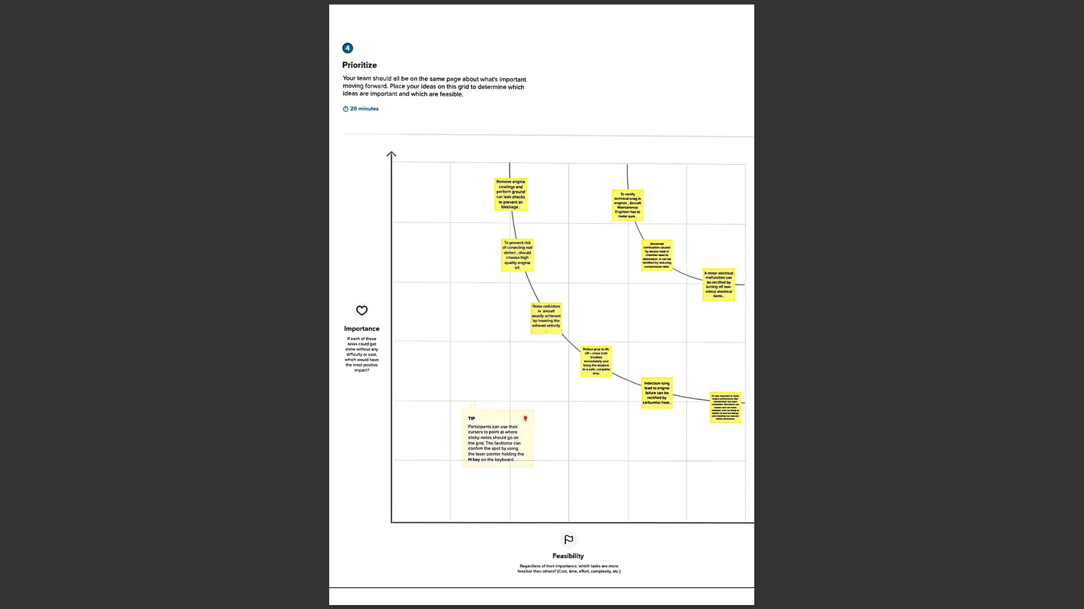

This is a graph between feasibility and importance .

**3.Result**

If the engine failure occurs when the aircraft is traveling very slowly, the aircraft should be kept on the ground and brought to a stop at some safe location off the runway. Conversely, if the engine failure occurs when the aircraft is close to the takeoff speed the takeoff should be continued.

The fail safe design established by boeing required that the fuselage be able to withstand 40-inch crack without suffering a catastrophic failure . Boeings design include the placement of tear straps with 10 inch spacing in the fuselage skin to redirect running cracks from external damage .

**4.Advantages & Disadvantages :**

**4.1.Advantages :**

* Wing mounted engine reduce wing bending moments.
* Wing does not have to be strong,reducing weight & complexity.
* Gravity fuel feeding is possible in the event of fuel pimp failure.
* It is lot easier to maintain such as oil top ups very convenient for the maintennance engineers.

**4.2. Disadvantages :**

* Aircraft requires longer landing gear,as engines lie low,the landing gear need to be longer to ensure good enough around clearance .
* The engines are more susceptible to Foreign Object Damage (FOD),as engine are closer to ground,in high power conditions they can suck in debris which could damage the engine components.
* It negatively affects the longitudinal (pitch) stability of the aircraft .
* When power is added ,it genetrates a noseup moment ,which reduces pitch stability.This may require a larger horizontal stabilizer design.

**5. Applications:**

* Flush the cooling system Relace engine oil on a regular basis.
* Check for oil leaks
* Replace the fuel filter Change the wires and sparks plugs occassionly.
* If your engine fails and you lose power,emergency flashers,find a safe area to pull over at ,and then pull off road where it is safe to do so.

**6.Conclusion**

Finally we would like to conclude that aeronaut has to take the following measures to reduce such aviation accidents. such as fly on nonstop routings , pay attention to the preflight briefing , keep the overhead storage bin free of heavy articles.

**7. Future scope**

Advanced engine architectures such as open fan,hybrid electric propulsion systems,and a new compact engine core designs The most important dimensions in 2030, ''With thus comprehensive ten -dimensional vision,

We will create an India where poverty,malnutrition,littering and illliteracy would be a matter of the past.

The safety of flights encompassing also associated and support services,which can have an impact on safety,for example Air navigation services,Aerodome operations management.

**8. Appendix**

|  |  |
| --- | --- |
|  | <!DOCTYPE html> |
|  | <html lang="en"> |
|  |  |
|  | <head> |
|  | <meta charset="utf-8"> |
|  | <meta content="width=device-width, initial-scale=1.0" name="viewport"> |
|  |  |
|  | <title>SHPVIBE - Airplane Crash</title> |
|  | <meta content="" name="description"> |
|  | <meta content="" name="keywords"> |
|  |  |
|  | <!-- Favicons --> |
|  | <link href="assets/img/favicon.png" rel="icon"> |
|  | <link href="assets/img/apple-touch-icon.png" rel="apple-touch-icon"> |
|  |  |
|  | <!-- Google Fonts --> |
|  | <link href="<https://fonts.googleapis.com/css?family=Open+Sans:300,300i,400,400i,600,600i,700,700i|Jost:300,300i,400,400i,500,500i,600,600i,700,700i|Poppins:300,300i,400,400i,500,500i,600,600i,700,700i>" rel="stylesheet"> |
|  |  |
|  | <!-- Vendor CSS Files --> |
|  | <link href="assets/vendor/aos/aos.css" rel="stylesheet"> |
|  | <link href="assets/vendor/bootstrap/css/bootstrap.min.css" rel="stylesheet"> |
|  | <link href="assets/vendor/bootstrap-icons/bootstrap-icons.css" rel="stylesheet"> |
|  | <link href="assets/vendor/boxicons/css/boxicons.min.css" rel="stylesheet"> |
|  | <link href="assets/vendor/glightbox/css/glightbox.min.css" rel="stylesheet"> |
|  | <link href="assets/vendor/remixicon/remixicon.css" rel="stylesheet"> |
|  | <link href="assets/vendor/swiper/swiper-bundle.min.css" rel="stylesheet"> |
|  |  |
|  | <!-- Template Main CSS File --> |
|  | <link href="assets/css/style.css" rel="stylesheet"> |
|  |  |
|  | <!-- ======================================================= |
|  | * Template Name: Arsha - v4.9.1 |
|  | * Template URL: https://bootstrapmade.com/arsha-free-bootstrap-html-template-corporate/ |
|  | * Author: BootstrapMade.com |
|  | * License: https://bootstrapmade.com/license/ |
|  | ======================================================== --> |
|  | </head> |
|  |  |
|  | <body> |
|  |  |
|  | <!-- ======= Header ======= --> |
|  | <header id="header" class="fixed-top "> |
|  | <div class="container d-flex align-items-center"> |
|  |  |
|  | <h1 class="logo me-auto"><a href="index.html">SHPVIBE</a></h1> |
|  | <!-- Uncomment below if you prefer to use an image logo --> |
|  | <!-- <a href="index.html" class="logo me-auto"><img src="assets/img/logo.png" alt="" class="img-fluid"></a>--> |
|  |  |
|  | <nav id="navbar" class="navbar"> |
|  | <ul> |
|  | <li><a class="nav-link scrollto active" href="#hero">Home</a></li> |
|  | <li><a class="nav-link scrollto" href="#about">About</a></li> |
|  |  |
|  |  |
|  | <li><a class="nav-link scrollto" href="#team">Dashboard</a></li> |
|  |  |
|  | <li><a class="nav-link scrollto" href="#pricing">Story</a></li> |
|  |  |
|  | <li><a class="nav-link scrollto" href="#contact">Contact</a></li> |
|  | <li><a class="getstarted scrollto" href="#about">Get Started</a></li> |
|  | </ul> |
|  | <i class="bi bi-list mobile-nav-toggle"></i> |
|  | </nav><!-- .navbar --> |
|  |  |
|  | </div> |
|  | </header><!-- End Header --> |
|  |  |
|  | <!-- ======= Hero Section ======= --> |
|  | <section id="hero" class="d-flex align-items-center"> |
|  |  |
|  | <div class="container"> |
|  | <div class="row"> |
|  | <div class="col-lg-6 d-flex flex-column justify-content-center pt-4 pt-lg-0 order-2 order-lg-1" data-aos="fade-up" data-aos-delay="200"> |
|  | <h1>Airplane Crash analysis</h1> |
|  | <h2>Airplane Crashes and Fatalities Since 1908</h2> |
|  | <div class="d-flex justify-content-center justify-content-lg-start"> |
|  | <a href="#about" class="btn-get-started scrollto">Get Started</a> |
|  | <a href="<https://www.youtube.com/@thesmartbridge/videos>" class="glightbox btn-watch-video"><i class="bi bi-play-circle"></i><span>Watch Video</span></a> |
|  | </div> |
|  | </div> |
|  | <div class="col-lg-6 order-1 order-lg-2 hero-img" data-aos="zoom-in" data-aos-delay="200"> |
|  | <img src="assets/img/a1.jpg" class="img-fluid animated" alt=""> |
|  | </div> |
|  | </div> |
|  | </div> |
|  |  |
|  | </section><!-- End Hero --> |
|  |  |
|  | <main id="main"> |
|  | <!-- ======= About Us Section ======= --> |
|  | <section id="about" class="about"> |
|  | <div class="container" data-aos="fade-up"> |
|  |  |
|  | <div class="section-title"> |
|  | <h2>About Project</h2> |
|  | </div> |
|  |  |
|  | <div class="row content"> |
|  | <div class="col-lg-6"> |
|  | <p> |
|  | An aviation accident is defined by the Convention on International Civil Aviation Annex 13 as an occurrence associated with the operation of an aircraft, which takes place from the time any person boards the aircraft with the intention of flight until all such persons have disembarked, and in which |
|  | </p> |
|  | <ul> |
|  | <li><i class="ri-check-double-line"></i> a) a person is fatally or seriously injured, </li> |
|  | <li><i class="ri-check-double-line"></i> b) the aircraft sustains significant damage or structural failure, or </li> |
|  | <li><i class="ri-check-double-line"></i> c) the aircraft goes missing or becomes completely inaccessible.</li> |
|  | </ul> |
|  | </div> |
|  | <div class="col-lg-6 pt-4 pt-lg-0"> |
|  | <p> |
|  | This dataset includes: |
|  | <ul> |
|  | <li><i class="ri-check-double-line"></i> All civil and commercial aviation accidents of scheduled and non-scheduled passenger airliners worldwide, which resulted in a fatality (including all U.S. Part 121 and Part 135 fatal accidents)</li> |
|  | <li><i class="ri-check-double-line"></i> All cargo, positioning, ferry and test flight fatal accidents.</li> |
|  | <li><i class="ri-check-double-line"></i> All military transport accidents with 10 or more fatalities.</li> |
|  | <li><i class="ri-check-double-line"></i> All commercial and military helicopter accidents with greater than 10 fatalities.</li> |
|  | <li><i class="ri-check-double-line"></i> All civil and military airship accidents involving fatalities.</li> |
|  | <li><i class="ri-check-double-line"></i> Aviation accidents involving the death of famous people.</li> |
|  | </ul> |
|  | </p> |
|  | </div> |
|  | </div> |
|  |  |
|  | </div> |
|  | </section><!-- End About Us Section --> |
|  |  |
|  | <!-- ======= Cta Section ======= --> |
|  | <section id="cta" class="cta"> |
|  | <div class="container" data-aos="zoom-in"> |
|  |  |
|  | <div class="row"> |
|  | <div class="col-lg-9 text-center text-lg-start"> |
|  | <h3>Call To Action</h3> |
|  | </div> |
|  | <div class="col-lg-3 cta-btn-container text-center"> |
|  | <a class="cta-btn align-middle" href="#">Call To Action</a> |
|  | </div> |
|  | </div> |
|  |  |
|  | </div> |
|  | </section><!-- End Cta Section --> |
|  | <!-- ======= Team Section ======= --> |
|  | <section id="team" class="team section-bg"> |
|  | <div class="container" data-aos="fade-up"> |
|  |  |
|  | <div class="section-title"> |
|  | <h2>Dashboard</h2> |
|  | </div> |
|  | <div class='tableauPlaceholder' id='viz1681294594207' style='position: relative'><noscript><a href='#'><img alt='Dashboard 1 ' src='https:&#47;&#47;public.tableau.com&#47;static&#47;images&#47;Bo&#47;Book1_16812936351260&#47;Dashboard1&#47;1_rss.png' style='border: none' /></a></noscript><object class='tableauViz' style='display:none;'><param name='host_url' value='https%3A%2F%2Fpublic.tableau.com%2F' /> <param name='embed_code_version' value='3' /> <param name='site_root' value='' /><param name='name' value='Book1_16812936351260&#47;Dashboard1' /><param name='tabs' value='no' /><param name='toolbar' value='yes' /><param name='static_image' value='https:&#47;&#47;public.tableau.com&#47;static&#47;images&#47;Bo&#47;Book1_16812936351260&#47;Dashboard1&#47;1.png' /> <param name='animate_transition' value='yes' /><param name='display_static_image' value='yes' /><param name='display_spinner' value='yes' /><param name='display_overlay' value='yes' /><param name='display_count' value='yes' /><param name='language' value='en-US' /><param name='filter' value='publish=yes' /></object></div> <script type='text/javascript'> var divElement = document.getElementById('viz1681294594207'); var vizElement = divElement.getElementsByTagName('object')[0]; if ( divElement.offsetWidth > 800 ) { vizElement.style.width='1000px';vizElement.style.height='827px';} else if ( divElement.offsetWidth > 500 ) { vizElement.style.width='1000px';vizElement.style.height='827px';} else { vizElement.style.width='100%';vizElement.style.height='1527px';} var scriptElement = document.createElement('script'); scriptElement.src = 'https://public.tableau.com/javascripts/api/viz_v1.js'; vizElement.parentNode.insertBefore(scriptElement, vizElement); </script> |
|  |  |
|  | </div> |
|  | </section><!-- End Team Section --> |
|  |  |
|  | <!-- ======= Pricing Section ======= --> |
|  | <section id="pricing" class="pricing"> |
|  | <div class="container" data-aos="fade-up"> |
|  |  |
|  | <div class="section-title"> |
|  | <h2>Story</h2> |
|  | <div class='tableauPlaceholder' id='viz1681296271141' style='position: relative'><noscript><a href='#'><img alt='Story 1 ' src='https:&#47;&#47;public.tableau.com&#47;static&#47;images&#47;Bo&#47;Book2_16812962189410&#47;Story1&#47;1_rss.png' style='border: none' /></a></noscript><object class='tableauViz' style='display:none;'><param name='host_url' value='https%3A%2F%2Fpublic.tableau.com%2F' /> <param name='embed_code_version' value='3' /> <param name='site_root' value='' /><param name='name' value='Book2_16812962189410&#47;Story1' /><param name='tabs' value='no' /><param name='toolbar' value='yes' /><param name='static_image' value='https:&#47;&#47;public.tableau.com&#47;static&#47;images&#47;Bo&#47;Book2_16812962189410&#47;Story1&#47;1.png' /> <param name='animate_transition' value='yes' /><param name='display_static_image' value='yes' /><param name='display_spinner' value='yes' /><param name='display_overlay' value='yes' /><param name='display_count' value='yes' /><param name='language' value='en-US' /><param name='filter' value='publish=yes' /></object></div> <script type='text/javascript'> var divElement = document.getElementById('viz1681296271141'); var vizElement = divElement.getElementsByTagName('object')[0]; vizElement.style.width='1016px';vizElement.style.height='991px'; var scriptElement = document.createElement('script'); scriptElement.src = 'https://public.tableau.com/javascripts/api/viz_v1.js'; vizElement.parentNode.insertBefore(scriptElement, vizElement); </script> |
|  |  |
|  | </div> |
|  | </section><!-- End Pricing Section --> |
|  |  |
|  |  |
|  | <!-- ======= Contact Section ======= --> |
|  | <section id="contact" class="contact"> |
|  | <div class="container" data-aos="fade-up"> |
|  |  |
|  | <div class="section-title"> |
|  | <h2>Contact</h2> |
|  | </div> |
|  |  |
|  | <div class="row"> |
|  |  |
|  | <div class="col-lg-5 d-flex align-items-stretch"> |
|  | <div class="info"> |
|  | <div class="address"> |
|  | <i class="bi bi-geo-alt"></i> |
|  | <h4>Location:</h4> |
|  | <p>xxxxxx Street, xxx, xx 53xxx2</p> |
|  | </div> |
|  |  |
|  | <div class="email"> |
|  | <i class="bi bi-envelope"></i> |
|  | <h4>Email:</h4> |
|  | <p>info@example.com</p> |
|  | </div> |
|  |  |
|  | <div class="phone"> |
|  | <i class="bi bi-phone"></i> |
|  | <h4>Call:</h4> |
|  | <p>+1 5xxx 5xxx8 5xs</p> |
|  | </div> |
|  |  |
|  | <iframe src="<https://www.google.com/maps/embed?pb=!1m14!1m8!1m3!1d12097.433213460943!2d-74.0062269!3d40.7101282!3m2!1i1024!2i768!4f13.1!3m3!1m2!1s0x0%3A0xb89d1fe6bc499443!2sDowntown+Conference+Center!5e0!3m2!1smk!2sbg!4v1539943755621>" frameborder="0" style="border:0; width: 100%; height: 290px;" allowfullscreen></iframe> |
|  | </div> |
|  |  |
|  | </div> |
|  |  |
|  | <div class="col-lg-7 mt-5 mt-lg-0 d-flex align-items-stretch"> |
|  | <form action="forms/contact.php" method="post" role="form" class="php-email-form"> |
|  | <div class="row"> |
|  | <div class="form-group col-md-6"> |
|  | <label for="name">Your Name</label> |
|  | <input type="text" name="name" class="form-control" id="name" required> |
|  | </div> |
|  | <div class="form-group col-md-6"> |
|  | <label for="name">Your Email</label> |
|  | <input type="email" class="form-control" name="email" id="email" required> |
|  | </div> |
|  | </div> |
|  | <div class="form-group"> |
|  | <label for="name">Subject</label> |
|  | <input type="text" class="form-control" name="subject" id="subject" required> |
|  | </div> |
|  | <div class="form-group"> |
|  | <label for="name">Message</label> |
|  | <textarea class="form-control" name="message" rows="10" required></textarea> |
|  | </div> |
|  | <div class="my-3"> |
|  | <div class="loading">Loading</div> |
|  | <div class="error-message"></div> |
|  | <div class="sent-message">Your message has been sent. Thank you!</div> |
|  | </div> |
|  | <div class="text-center"><button type="submit">Send Message</button></div> |
|  | </form> |
|  | </div> |
|  |  |
|  | </div> |
|  |  |
|  | </div> |
|  | </section><!-- End Contact Section --> |
|  |  |
|  | </main><!-- End #main --> |
|  |  |
|  | <!-- ======= Footer ======= --> |
|  | <footer id="footer"> |
|  |  |
|  | <div class="footer-newsletter"> |
|  | <div class="container"> |
|  | <div class="row justify-content-center"> |
|  | <div class="col-lg-6"> |
|  | <h4>Join Our Newsletter</h4> |
|  |  |
|  | <form action="" method="post"> |
|  | <input type="email" name="email"><input type="submit" value="Subscribe"> |
|  | </form> |
|  | </div> |
|  | </div> |
|  | </div> |
|  | </div> |
|  |  |
|  | <div class="footer-top"> |
|  | <div class="container"> |
|  | <div class="row"> |
|  |  |
|  |  |
|  |  |
|  | <div class="col-lg-3 col-md-6 footer-links"> |
|  | <h4>Useful Links</h4> |
|  | <ul> |
|  | <li><i class="bx bx-chevron-right"></i> <a href="#hero">Home</a></li> |
|  | <li><i class="bx bx-chevron-right"></i> <a href="#about">About</a></li> |
|  | <li><i class="bx bx-chevron-right"></i> <a href="#portfolio">Charts</a></li> |
|  | <li><i class="bx bx-chevron-right"></i> <a href="#team">Dashboard</a></li> |
|  | <li><i class="bx bx-chevron-right"></i> <a href="#pricing">Story</a></li> |
|  | </ul> |
|  | </div> |
|  |  |
|  | <div class="col-lg-3 col-md-6 footer-links"> |
|  | <h4></h4> |
|  | <ul> |
|  |  |
|  | </ul> |
|  | </div> |
|  | <div class="col-lg-3 col-md-6 footer-links"> |
|  | <h4></h4> |
|  | <ul> |
|  |  |
|  | </ul> |
|  | </div> |
|  |  |
|  | <div class="col-lg-3 col-md-6 footer-links"> |
|  | <h4>Our Social Networks</h4> |
|  |  |
|  | <div class="social-links mt-3"> |
|  | <a href="<https://www.linkedin.com/in/hariprabu741/>" class="linkedin"><i class="bx bxl-linkedin"></i></a> |
|  | <a href="#" class="twitter"><i class="bx bxl-twitter"></i></a> |
|  | <a href="#" class="facebook"><i class="bx bxl-facebook"></i></a> |
|  | <a href="#" class="instagram"><i class="bx bxl-instagram"></i></a> |
|  | <a href="#" class="google-plus"><i class="bx bxl-skype"></i></a> |
|  |  |
|  | </div> |
|  | </div> |
|  |  |
|  | </div> |
|  | </div> |
|  | </div> |
|  |  |
|  | <div class="container footer-bottom clearfix"> |
|  | <div class="copyright"> |
|  | &copy; Copyright <strong><span>SHPVIBE</span></strong>. All Rights Reserved |
|  | </div> |
|  | <div class="credits"> |
|  | <!-- All the links in the footer should remain intact. --> |
|  | <!-- You can delete the links only if you purchased the pro version. --> |
|  | <!-- Licensing information: https://bootstrapmade.com/license/ --> |
|  | <!-- Purchase the pro version with working PHP/AJAX contact form: https://bootstrapmade.com/arsha-free-bootstrap-html-template-corporate/ --> |
|  | Designed by <a href="<https://bootstrapmade.com/>">SHPVIBE</a> |
|  | </div> |
|  | </div> |
|  | </footer><!-- End Footer --> |
|  |  |
|  | <div id="preloader"></div> |
|  | <a href="#" class="back-to-top d-flex align-items-center justify-content-center"><i class="bi bi-arrow-up-short"></i></a> |
|  |  |
|  | <!-- Vendor JS Files --> |
|  | <script src="assets/vendor/aos/aos.js"></script> |
|  | <script src="assets/vendor/bootstrap/js/bootstrap.bundle.min.js"></script> |
|  | <script src="assets/vendor/glightbox/js/glightbox.min.js"></script> |
|  | <script src="assets/vendor/isotope-layout/isotope.pkgd.min.js"></script> |
|  | <script src="assets/vendor/swiper/swiper-bundle.min.js"></script> |
|  | <script src="assets/vendor/waypoints/noframework.waypoints.js"></script> |
|  | <script src="assets/vendor/php-email-form/validate.js"></script> |
|  |  |
|  | <!-- Template Main JS File --> |
|  | <script src="assets/js/main.js"></script> |
|  |  |
|  | </body> |
|  |  |
|  | </html> |
|  |  |
|  |  |